**Title of the Project:Hostel Management System**

**Group Number:09**

**Group Members:**

|  | **Student Name** |
| --- | --- |
|  | ANIKA TASNIM |
|  | NOWSHIN TASFIA |
|  | ANIKA MASUD |
|  |  |
|  |  |

# Introduction

The purpose of this project is to specify the software requirements, functionality and general interface of the Hostel Management System. It will also describe how the system will perform and the possible risks of this project. There are mainly two types of reader for this document. They are Hostel owner, system developer and system designer. The owner will agree on the features that they want to add on this project. The reader will get a basic idea how the project will be implemented by reading this document.

# Motivation

The goal of this project is to design a website for the management of the hostels in Dhaka. In this project we will automate the workings and procedures of the Hostel management system. Whenever any students come to take a seat , their information will be recorded in the student database and they will get a user account. Students can see their bills and dues here. They can submit any problem or feedback and can request for help from the administration. The administration can also track the attendance of the students for their safety and they will also maintain a database for the employees.

# 

# System Description

This system has the ability to improve access to student information. Through using this system, manual work will be reduced & also decrease the manual errors. Moreover, Transparency & user satisfaction will also be increased. The special focus of this system is to ensure proper security & give priority to the female students. All over, this system will reduce 15% administration cost

# Requirement analysis

* **Functional**-

There are two parts. Administrator and User. Administrators can have all the access to student information. Besides, they can easily check their payment , attendance & also search for the student database. User means the students. They can login their account, search for room & access for a due bill. Apart from these, they can also request the administrator for help.

* **Non-functional-**

Through this, the database will keep records of two thousands students. It will be supported in any browser & also able to run cellphone, tablets, laptops. So, it has lots of benefits to use.

Design diagram

**Use case:**

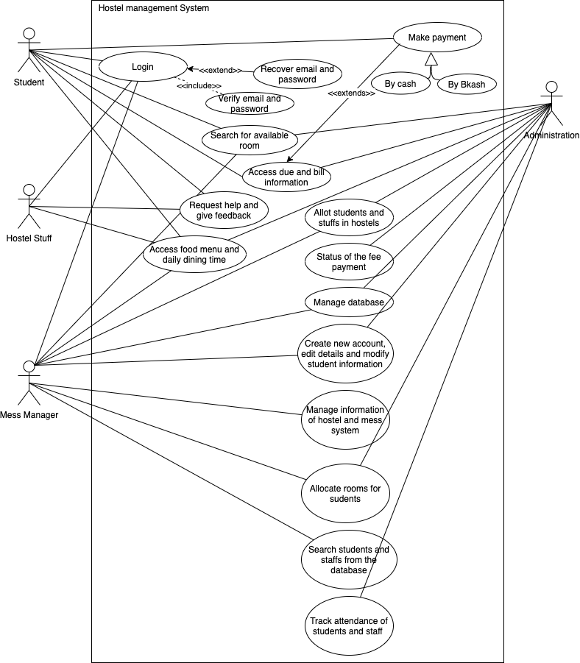

Use Case Name:

Hostel Management System

Actor:

Student, Hostel staff, Mess Manager, Administration

Description:

This use case describes how the hostel management works with the students, staff and administration

Trigger:

Students decide to allot themselves in the hostel

**Class diagram:**

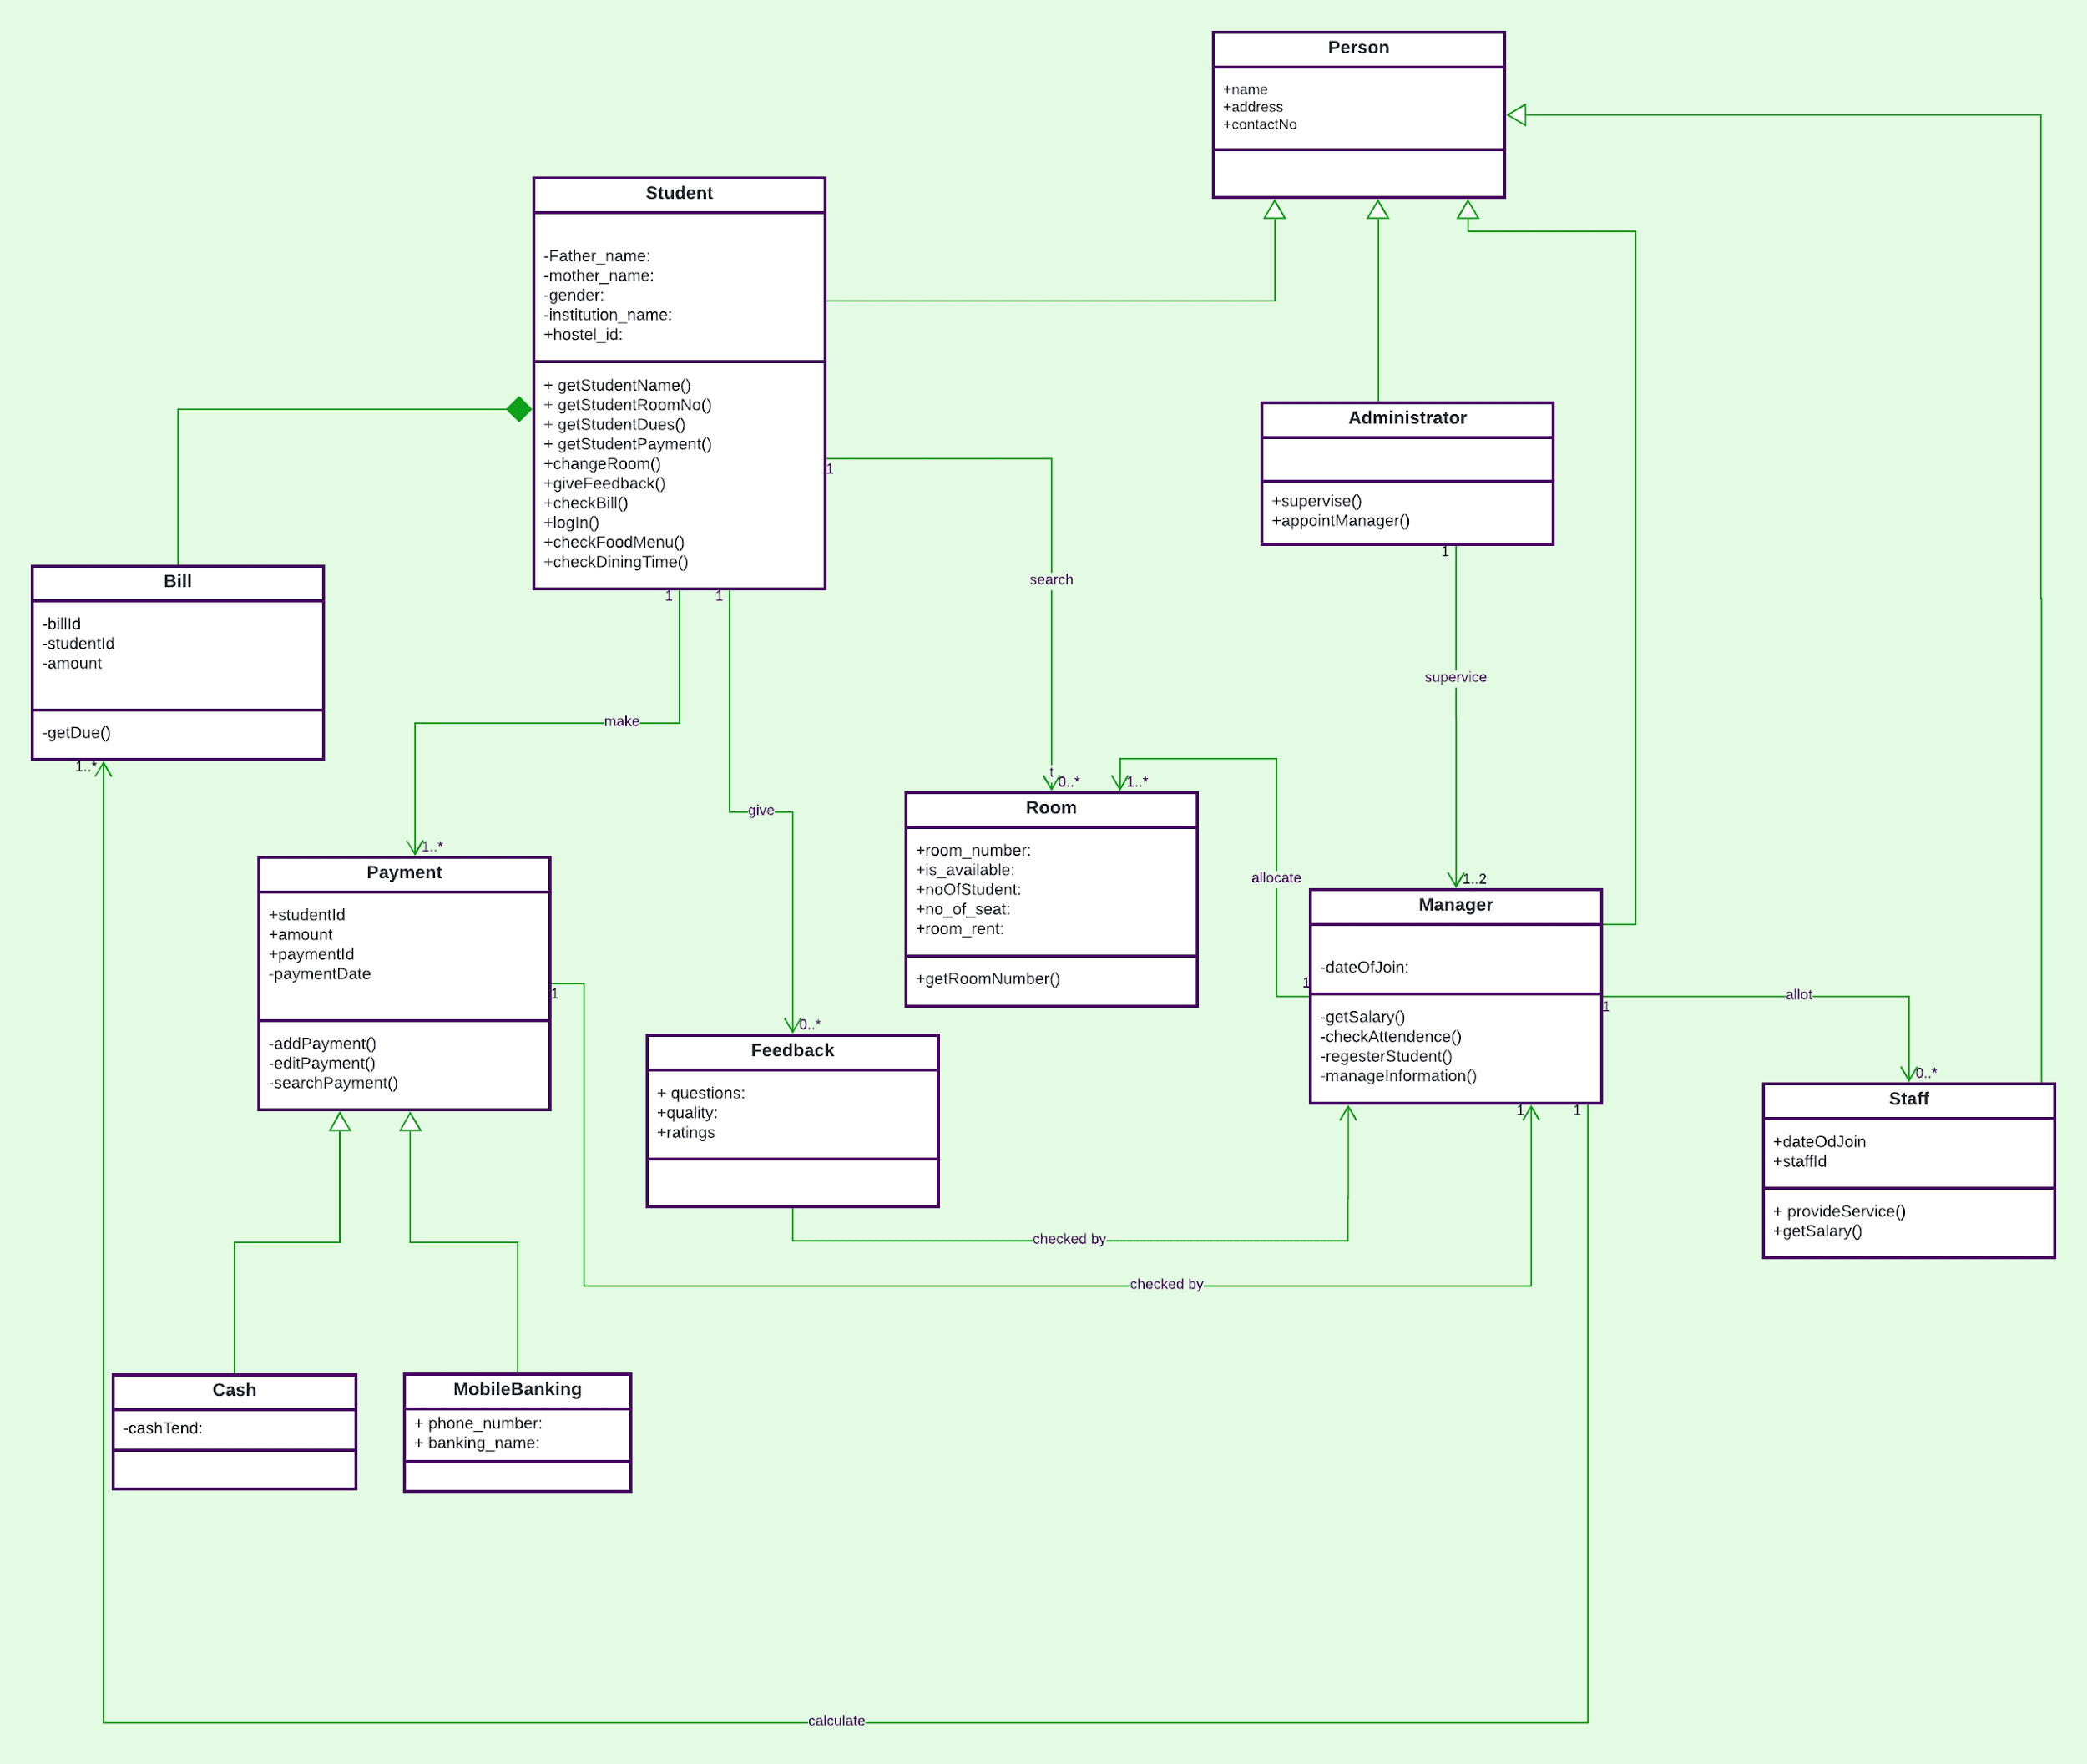

In this class diagram there are classes and the classes has attributes and method.there is aggregation between student and bill class .Cash and Mobile banking class generalize into Payment .And Student,Manager,administrator,staff class are generalized into Person class.Others have association

**Activity Diagram:**

ACTIVITY DIAGRAM DESCRIPTION:

We basically depict workflows visually using an activity diagram. An activity diagram focuses on the condition of flow & the sequence in which it happens. The short description of activity diagram that

we use for our project is given bellow:-

* **Room Allocation:**

In this diagram, User can search for a room & request for registration based on seat rent. Moreover, the Manager can allocate room for students through collecting their information ,creating student accounts & storing them in the student database & confirming student. Finally, students can collect their id from the manager.

* **Payment:**

Here, user will be able to check their bill & pay their bill through cash or mobile banking. Then, manager will check the money ,confirm them and send it to the administrator. Lastly, administrator will receive the money.

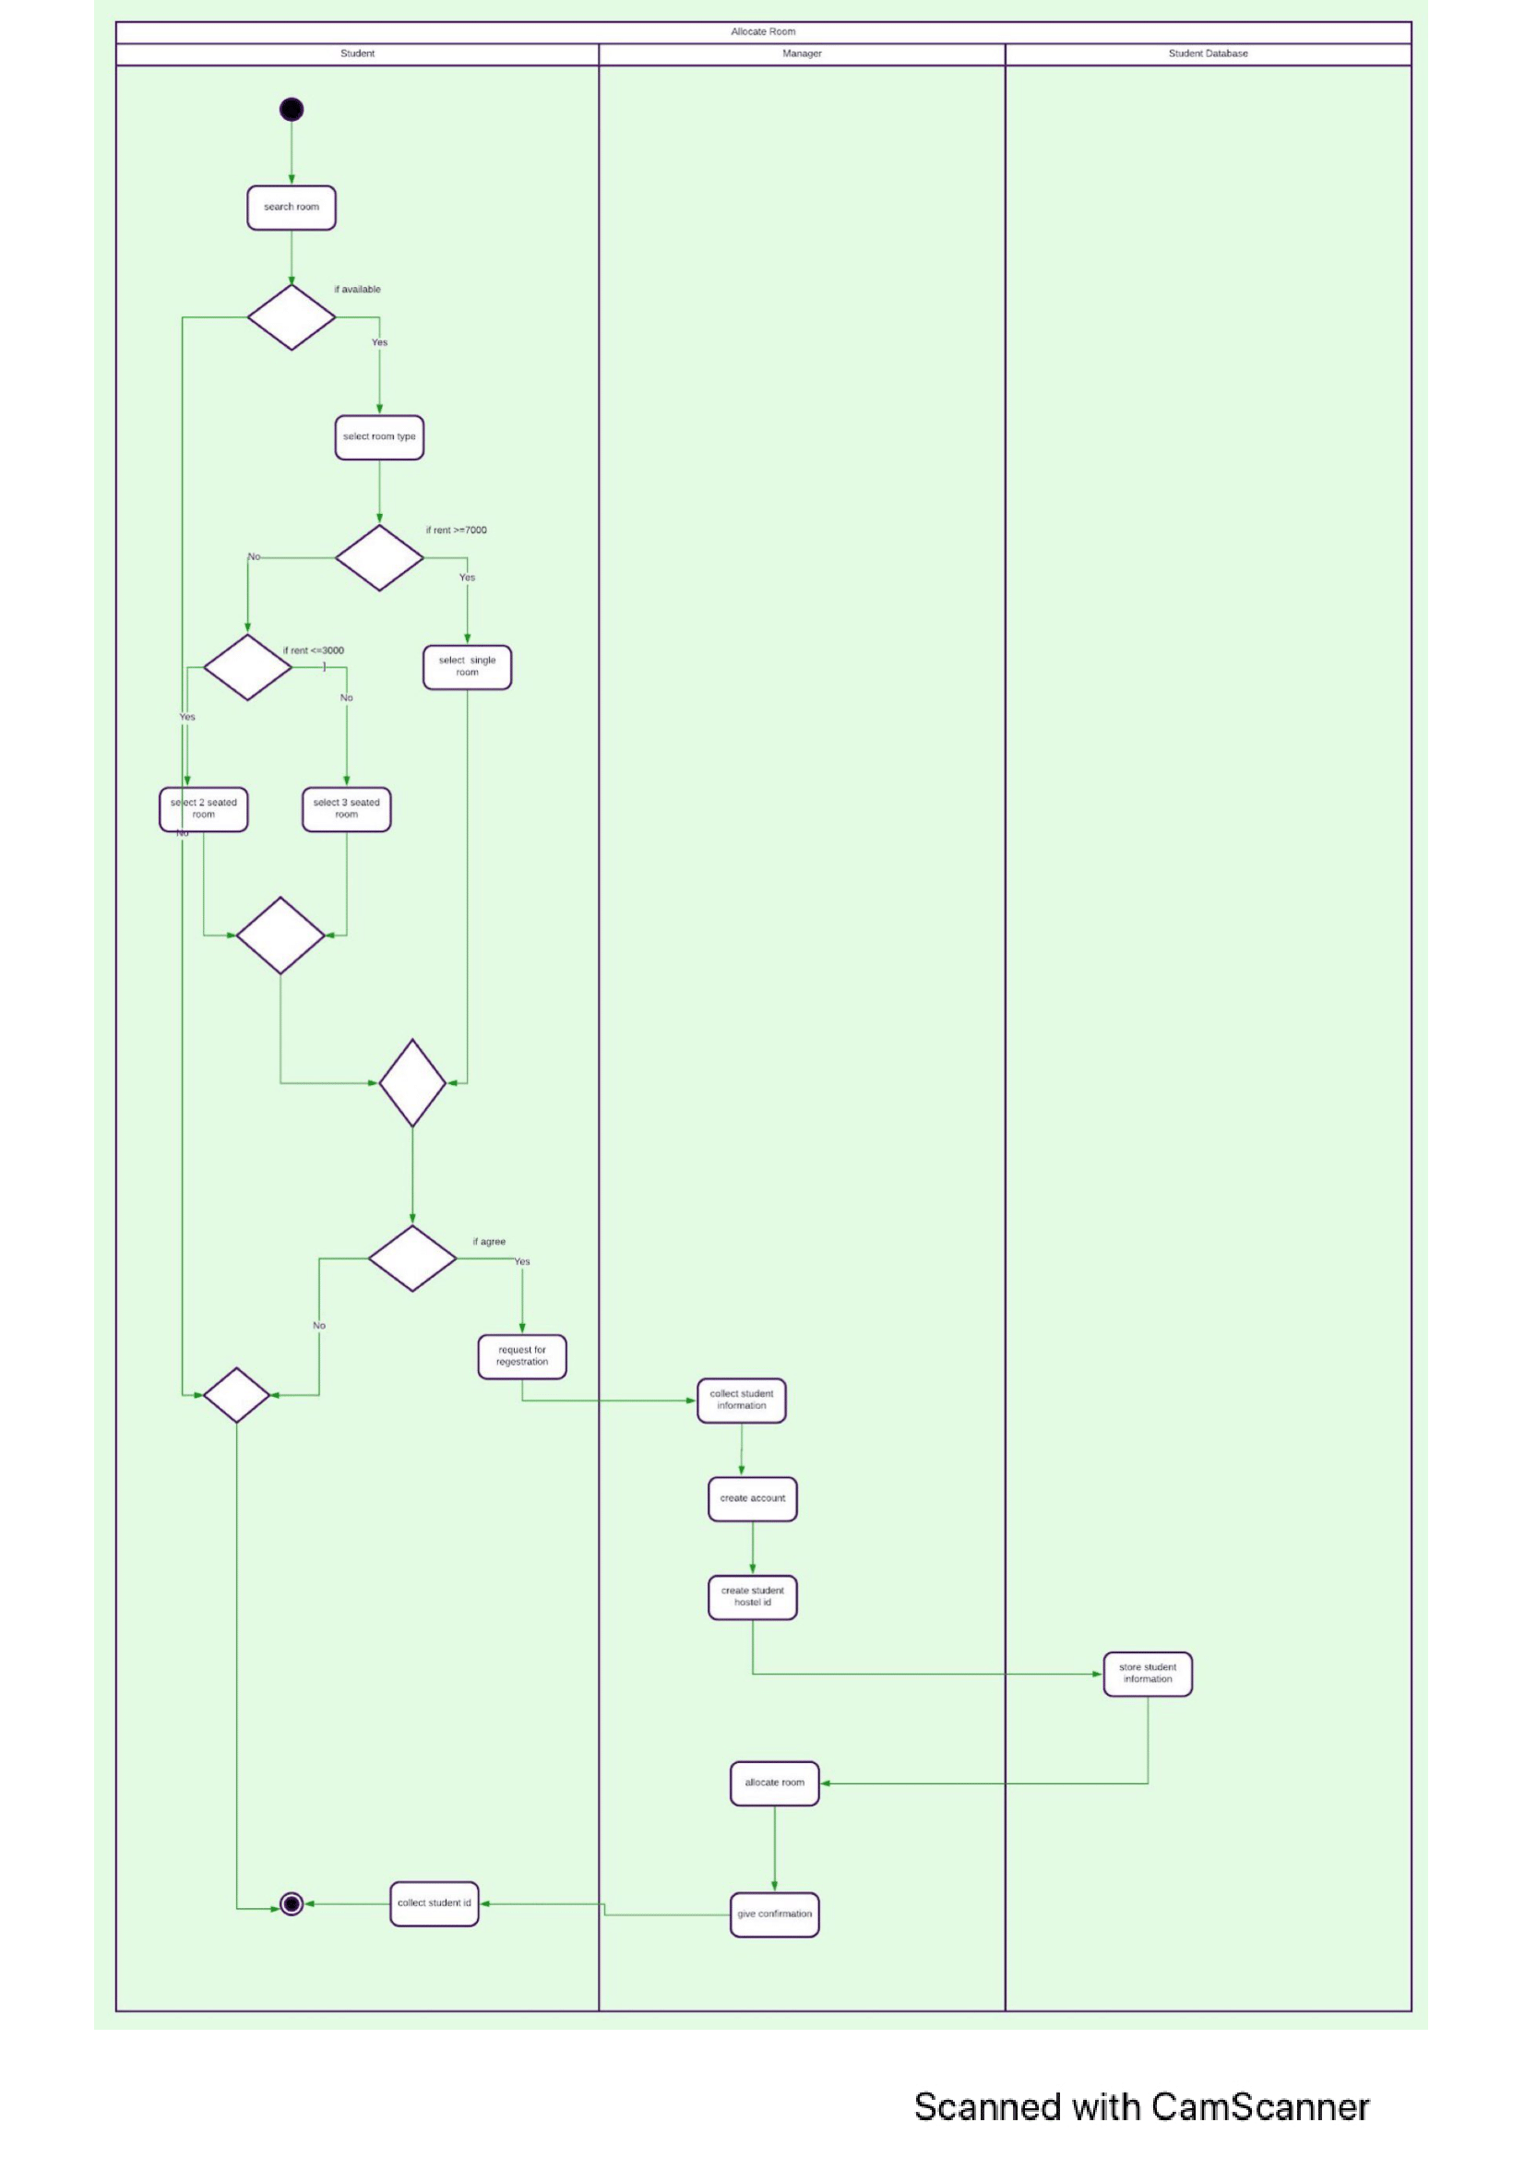

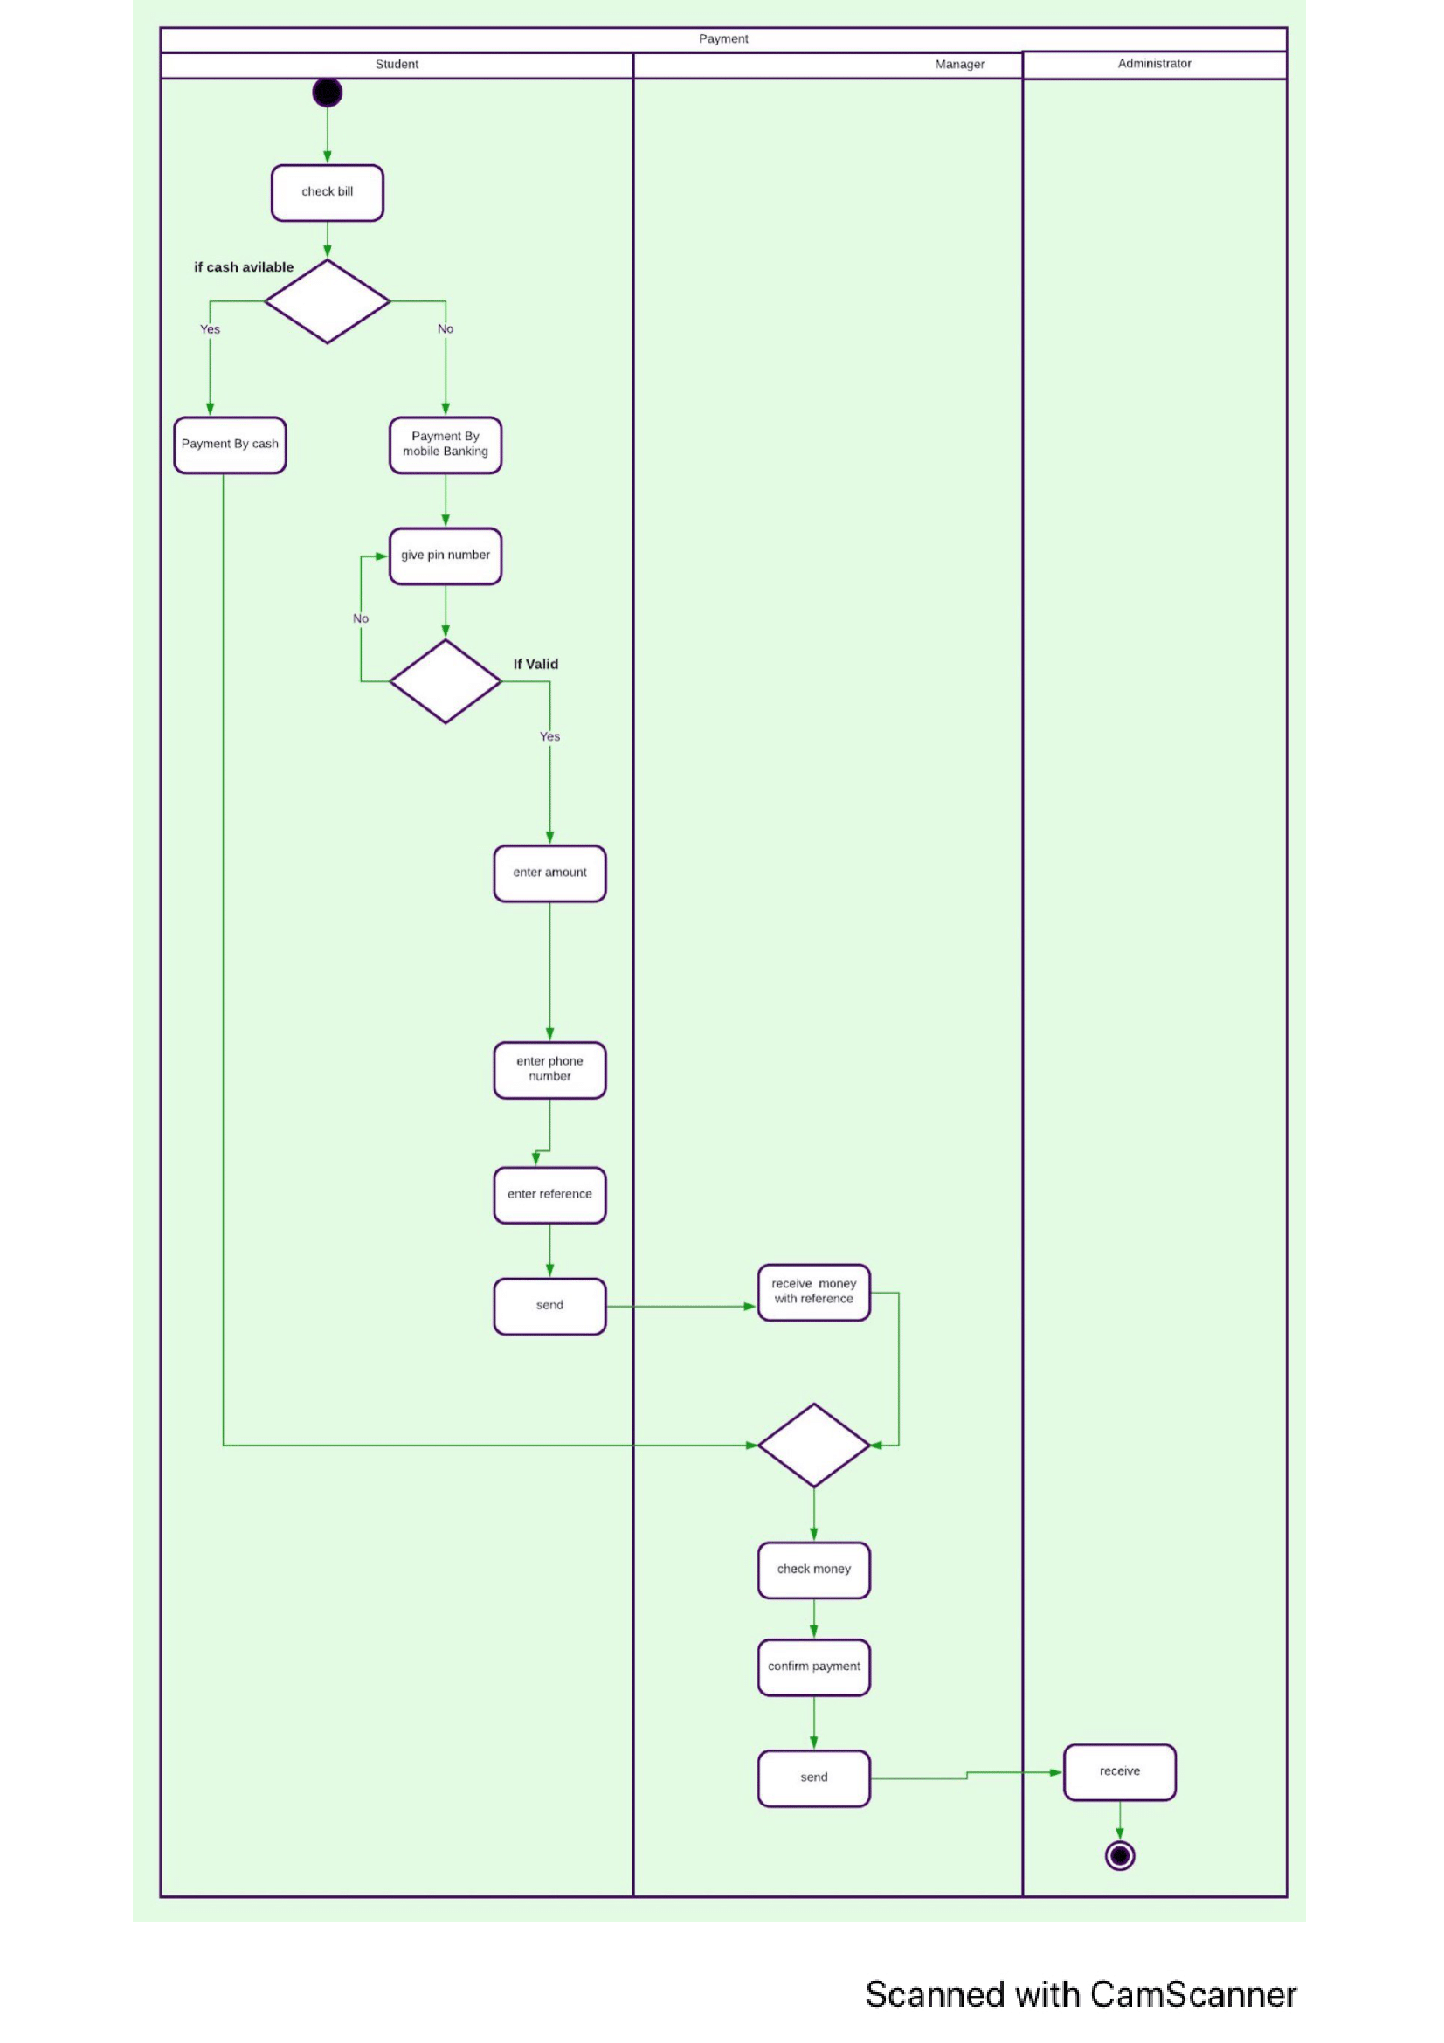

# **Sequence diagram**

# **Sequence Diagram.jpg**

Sequence Diagram Name:

Hostel Management System

Actor:

Student

Object:

Service, Hostel staff, Feedback, Manager, Payment

Description:

This sequence diagram describes how students interacts regarding facilities with hostel staff and manager in the hostel management system

Trigger:

Students decide to allot themselves in the hostel

Type: External

Preconditions:

* Students need to first get admitted in the hostel
* The website in online and user-friendly
* The users need to have basic computer skills

# **DFD:**

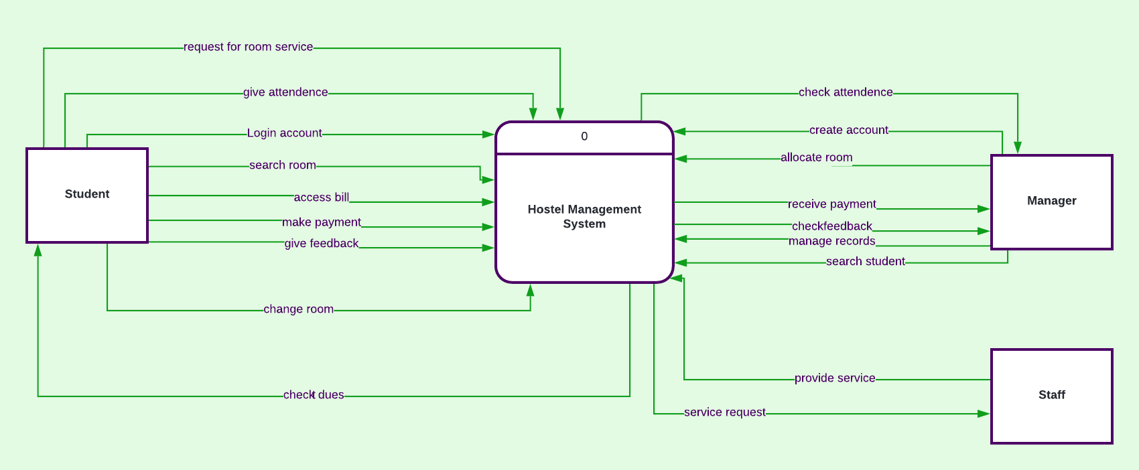

# This is the context diagram.Student ,manger,staff are the external entities and hostel management system is the process.There are also inputs and outputs.this is also called Level-0 diagram

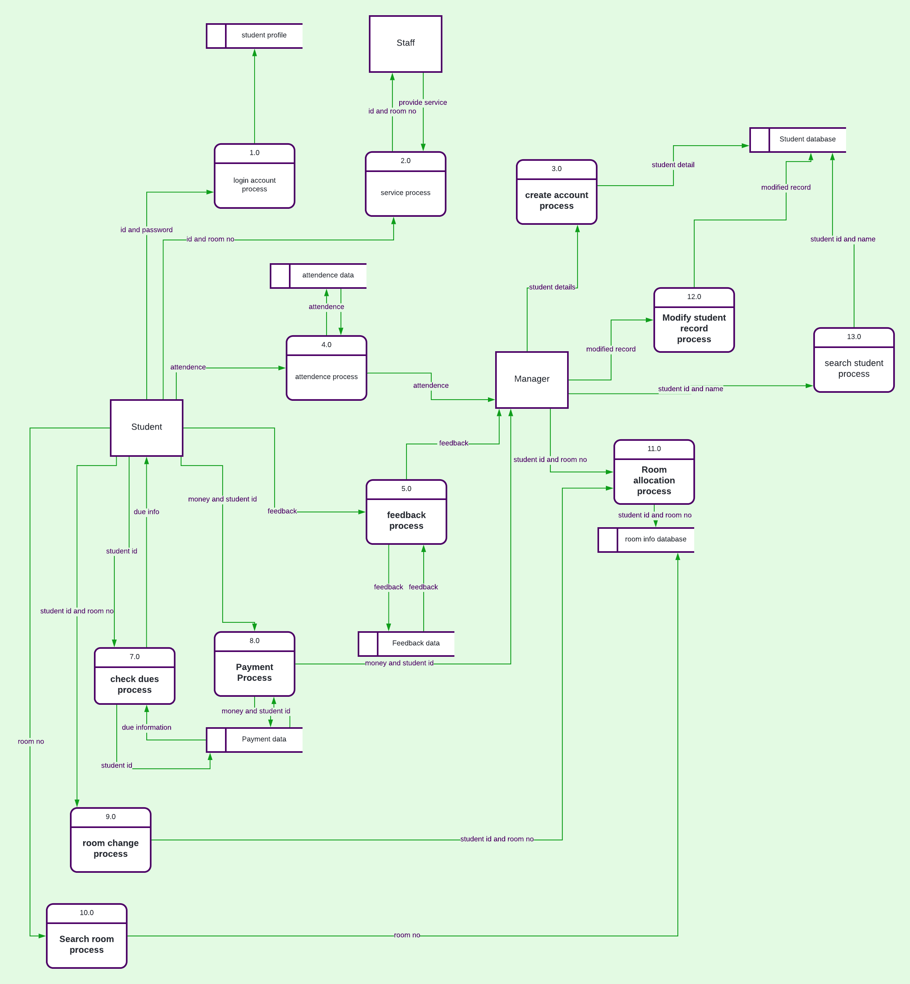

# This is the Level-1 Diagram.From the level-0 diagram we divide thie process into 13 subprocesses.This diagram also contain datastores.And the same number of input and output come in and out from the external entities.

# **Conclusion:**

ONLINE HOSTEL MANAGEMENT SYSTEM is very useful for hostel allotment and mess fee calculation . This hostel management software is designed for people who want to manage various activities in the hostel. For the past few years the numbers of educational institutions are increasing rapidly. Thereby the numbers of hostels are also increasing for the accommodation of the students studying in this institution. And hence there is a lot of strain on the person who are running the hostel and software’s are not usually used in this context. This particular project deals with the problems on managing a hostel and avoids the problems which occur when carried manually.